Kubernetes User Management

Managing Kubernetes user access traditionally involves juggling complex kubeconfig files and static RBAC roles. This often leads to security vulnerabilities, "privilege creep," and manual overhead. Border0 simplifies this by providing a centralized, identity-aware access proxy that integrates with your existing SSO (Google, GitHub, Azure AD) and enables Just-In-Time (JIT) access.

The Challenges of Traditional Kubernetes Management
- Kubeconfig Sprawl: Managing individual certs and tokens for dozens of users is a manual nightmare and increases the risk of credential leakage.
- Over-Privileged Access: Static Role-Based Access Control (RBAC) is often "set and forget," meaning users retain access long after they need it.
- Lack of JIT Access: Granting temporary production access to a developer often leads to "forgotten" permissions that remain active indefinitely.

The Solution: Border0
Border0 acts as a secure connector between your users and your infrastructure. It handles Authentication (who are you?) via SSO and Authorization (what can you do?) via centralized policies, all without exposing your cluster's IP address to the public internet.

Implementation Guide

1. Deploy the Border0 Connector
The connector is a lightweight agent that runs inside your cluster and establishes an outbound tunnel to the Border0 cloud.
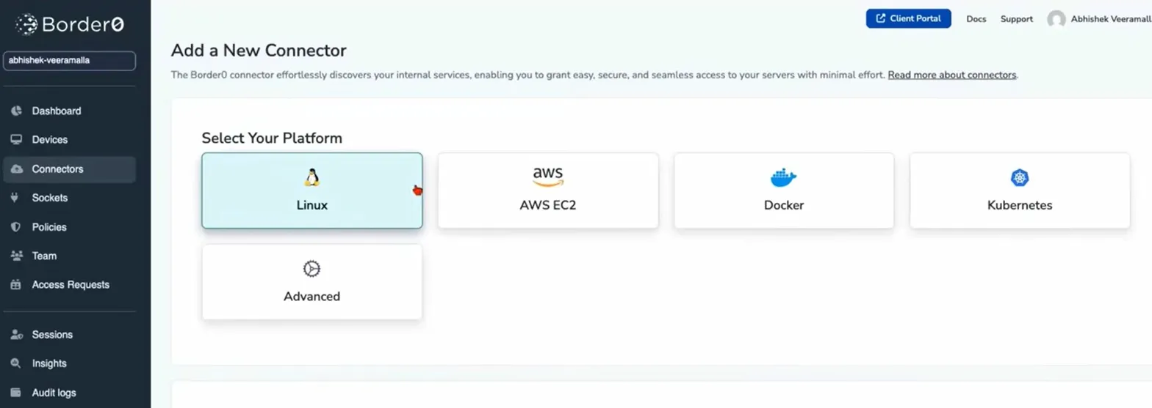
- Navigate to Connectors > Add a New Connector.
- Select the Kubernetes platform.
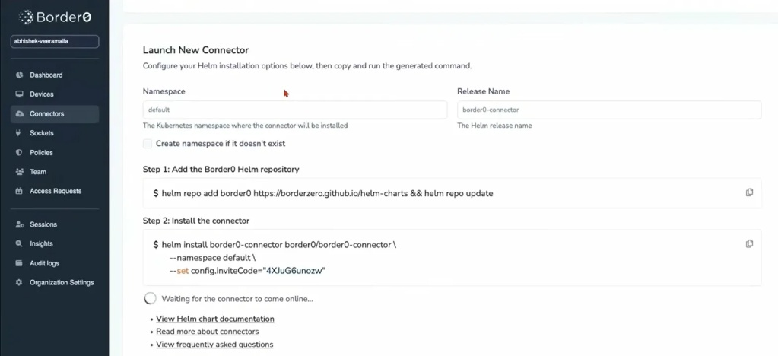
- Verify the connector is "Alive" in the Border0 dashboard.

2. Create a Kubernetes Socket
A Socket represents the specific service (your K8s API) you want to make available.
- In the Border0 dashboard, go to the Sockets tab.
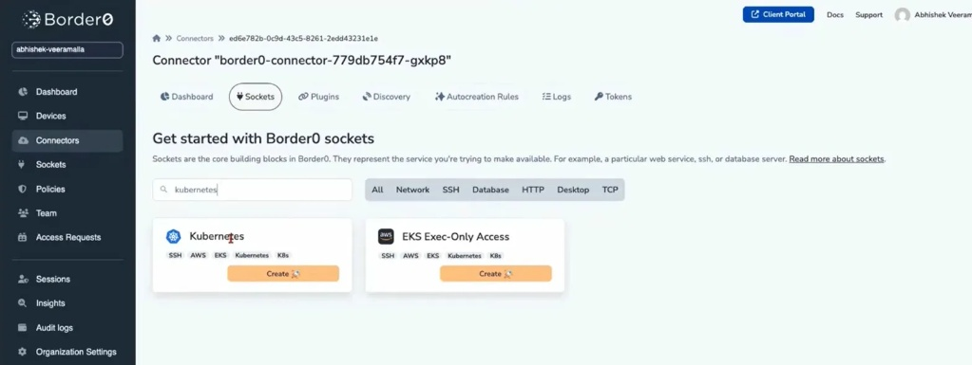
- Click Create Socket and select Kubernetes.

- Accept the default configuration. This creates a secure entry point tied to your active connector.
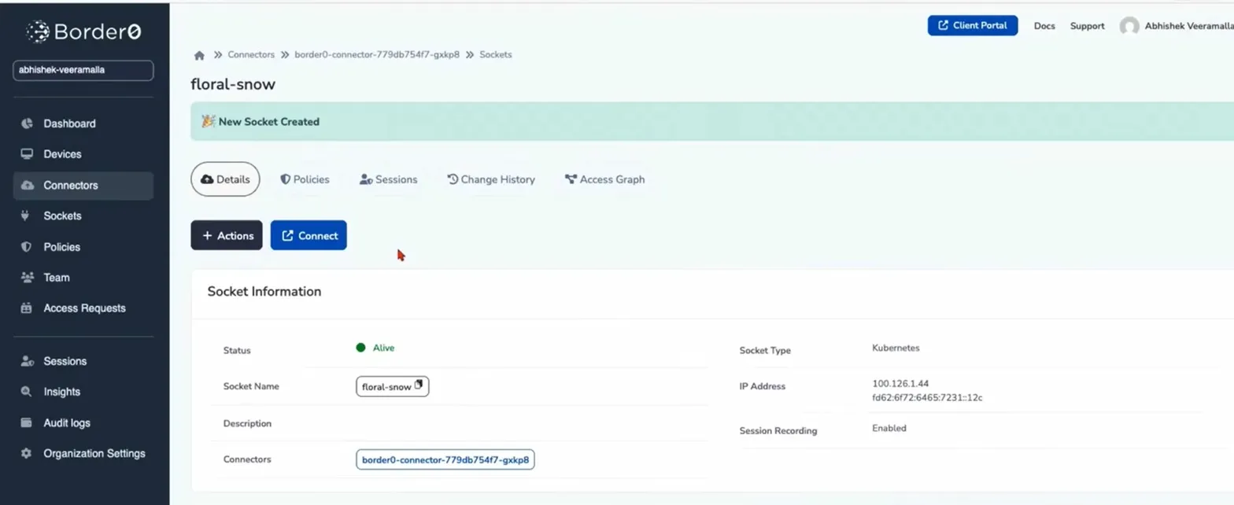

3. Define Fine-Grained Policies
Instead of complex YAML-based RoleBindings, use Border0's UI to define what users can do.
- Go to Policies > New Policy.
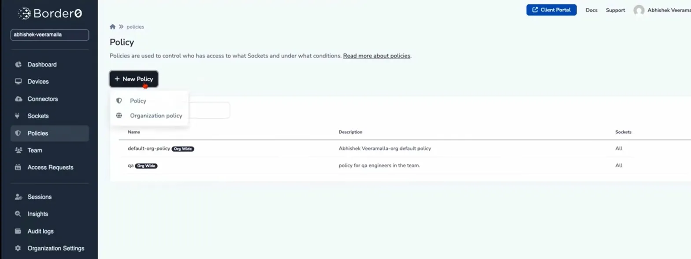
- Select the Kubernetes tab.
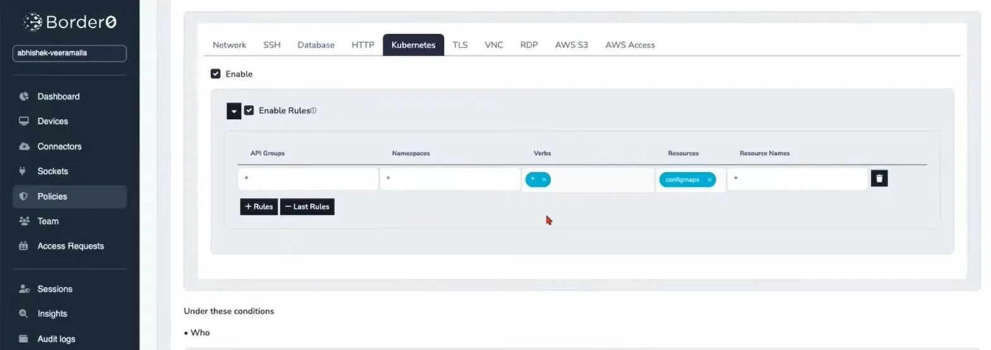
- Configure Rules: Specify allowed API Groups, Namespaces, and Verbs (e.g., allow get, list on configmaps but deny delete).
- Conditions: You can restrict access by time of day, IP location, or require MFA.

4. Team Onboarding and Policy Attachment
- Invite Users: Go to the Team tab to invite colleagues via their email.
- Attach Policy: Navigate back to your Socket > Policies tab. Select the policy you created (e.g., "developer-policy") and click Save Changes.
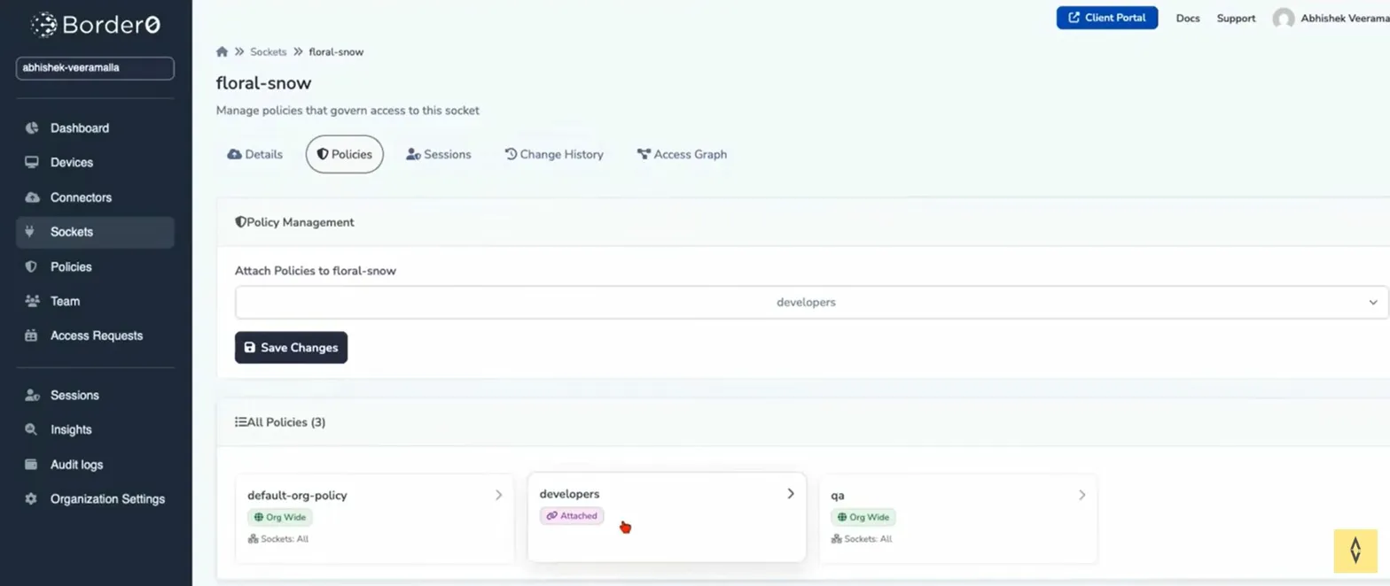

User Experience: Accessing the Cluster
Once configured, users no longer need a manual kubeconfig. They simply:
- Log in to the Border0 Client Portal or use the Border0 CLI.
- Click Connect on the Kubernetes socket.
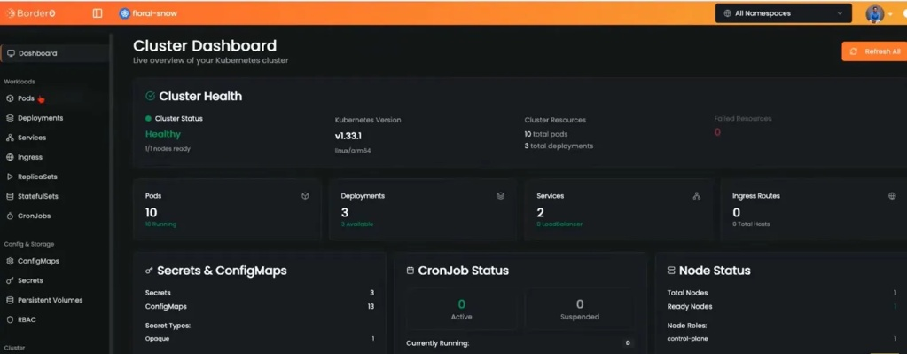
- Access a web-based Cluster Dashboard (as seen in your screenshot) to view Pods, Deployments, and Logs directly, or use their local kubectl via the secure tunnel.

Key Benefits
Feature | Traditional K8s Access | Border0 Solution
Authentication | Static Tokens/Certs | Identity-based SSO (GitHub/Google)
Visibility | Public IP exposure | Secure Outbound Tunnel (No public IP)
Audit Logs | Difficult to aggregate | Centralized session logs and recordings
Permission Duration | Permanent until revoked | Just-In-Time & Time-bound access

